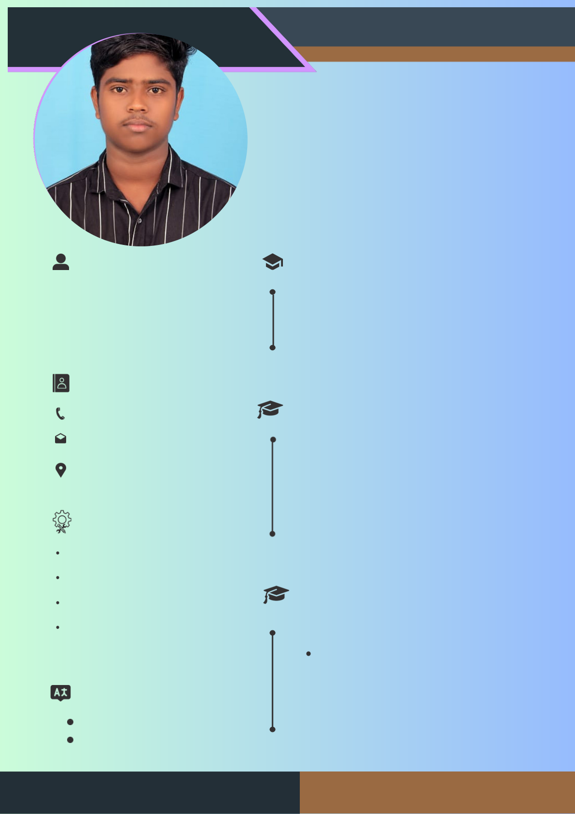

***RESUME***

VASANTH K

***COMPUTER SCIENCE***

**About Me**  **Education**

I'm a web development expert who is passionate **(2023-2026)**

|  |  |
| --- | --- |
| about creating dynamic and user-friendly  websites. I'm driven by the desire to craft high- | **BHARATHIDASAN_UNIVERSITY - BSC** |

|  |  |
| --- | --- |
| performance web applications that enhance user experience and provide seamless digital solutions. | Bachelor of Science |

**Contact**

**Experience**

91+8438066257

vasanth.kg2006@gmail.com

Ariyalur,Tamil Nadu **I am fresher**

No experience **Skills**

Web davalopment

|  |  |
| --- | --- |
| java  python | **Projects** |

Data base

personal Portfolio

**Language**

English

Tamil